Software Requirements Specification
for
Airline Reservation System

Prepared by
22401 Amit Singh
22402 Niraj Sahu
22415 Khushi Makwana

22/02/2023
Table of Contents
Table of Contents ii
1. Introduction 1
1.1 Purpose 1
1.2 Document Conventions 1
1.3 Intended Audience and Reading Suggestions 1
1.4 Product Scope 1
1.5 References 1
2. Overall Description 1
2.1 Product Perspective 1
2.2 Product Functions 2
2.3 User Classes and Characteristics 2
2.4 Operating Environment 2
3. External Interface Requirements 3
3.1 User Interfaces 3
3.2 Software Interfaces 6
4. System Features 6
4.1 Easy Login 6
4.2 Generating Ticket 6
5. Other Nonfunctional Requirements 6
5.1 Performance Requirements 6
5.2 Safety Requirements 6
5.3 Security Requirements 7
5.4 Software Quality Attributes 5
Glossary 7
Analysis Models 7

Introduction

Purpose
The purpose of this document is to provide a detailed description of the Airline Reservation System. It includes functional and non-functional requirements, user interfaces, and system interfaces.

Document Conventions
This Document was created based on IEEE template for System Requirement Specification Documents.

Intended Audience and Reading Suggestions
- Professional Users, such as Airline employees, who wants to use Airline Reservation System for Reservation/Booking the tickets.
- Programmers who are interested in working on the project by further developing it or fix existing bugs.

Product Scope
The scope of the Airline Reservation System includes the following:
- Booking of tickets for customers
- Reservation management for airlines
- Customer data management

References
IEEE Software Requirements Specification Template Document:
https://web.cs.dal.ca/~hawkey/3130/srs_template-ieee.doc

Overall Description

Product Perspective
Airline Reservation System was developed for the employees who are working in Booking counter of the Airports to make the Booking/Reservation easier for them.
It is an open-source project and it has a very active developer team to support it and provide feedback to users. It was developed to run on Windows, Mac OS, and Linux

Product Functions
- New project: Create a new project
- Open: Load the project
- Import Database: Load the database (MySQL)
- Save: Save the project
- Run: Run the project
- Exit: Close

User Classes and Characteristics
- Professional Users (Airport Employees)
- Programmers

Operating Environment
- Window 10
- Window 11
- Mac OS X
- Linux

External Interface Requirements

User Interfaces
- Login Page

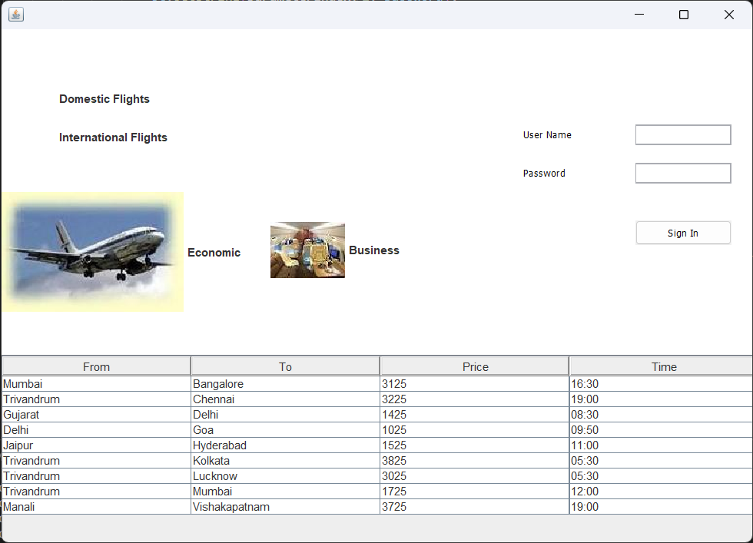

- Booking Page

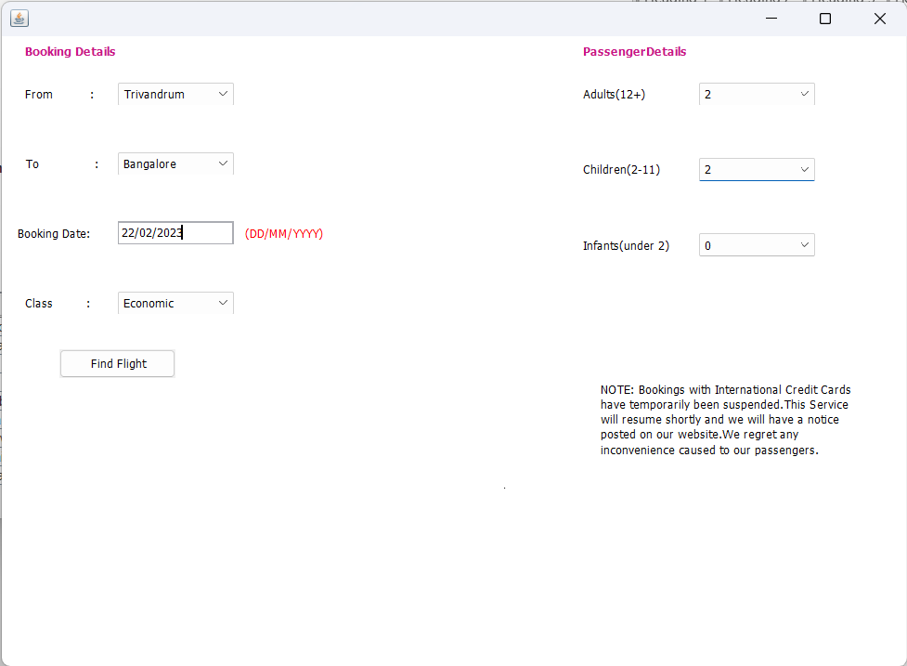

- Ticket Page

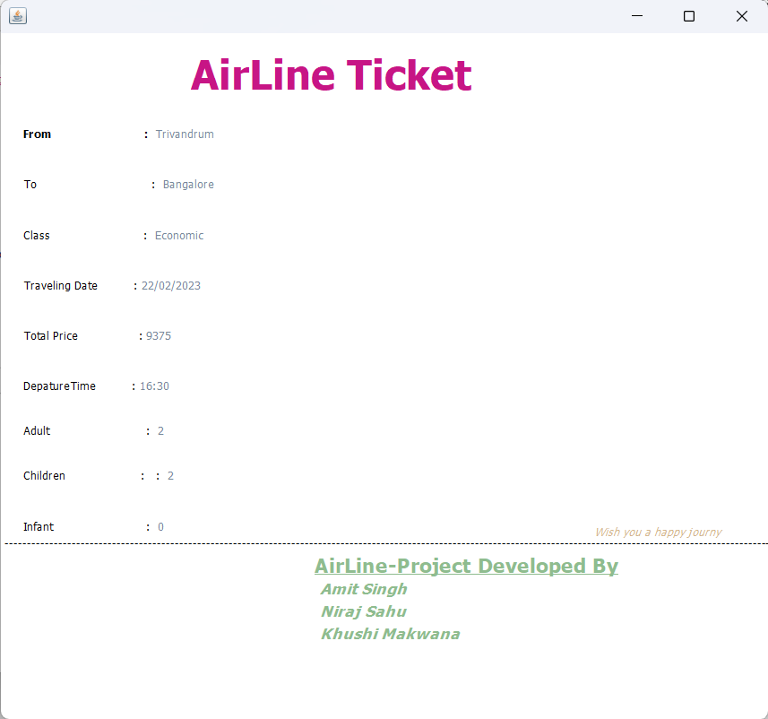

Software Interfaces
Airline Reservation System requires Java to be installed on the system, more specifically Java version 18 or 19 for its latest release.
Airline Reservation System can be connected to MySQL database to import the data list.

System Features
This section demonstrates Airline Reservation System’s most prominent features and explain how they can be used and the results they will give back to the user.

Easy Login
4.1.1 Description and Priority
User can directly interact with the Graphical User Interface (GUI) because of the GUI user will have no difficulty to Login into the system.
4.1.2 Stimulus/Response Sequences
If the username and password will be wrong then it will show the pop-up window that your username or password is invalid else the username and password is correct it will continue to the next page.

Generating Ticket
4.1.1 Description and Priority
User can see their information while generating the ticket.
4.1.2 Stimulus/Response Sequences
After giving the details the ticket is generated with all the information of the passenger.

Other Nonfunctional Requirements

Performance Requirements
Airline Reservation System requires a system with at least a 500-megahertz CPU and 128 megabytes of RAM and an OPENGL 1.2 compatible graphics card. Performance depends on the GUI components.

Safety Requirements
Airline Reservation System does not have any safety requirements because it is a software base system. It is not hardware system.

Security Requirements
To ensure that no one of Airline Reservation System’s users loses any data while using it (due to a
crash or a bug of some kind) the developer team updates it regularly.

Software Quality Attributes
Airline Reservation System provides the users with both simple and advanced features. Due to its well designed and easy to use interface it can be used by both experts and typical users. However, users must already have a basic knowledge of GUI before using it.
Glossary
In conclusion, the Airline reservation system provides a valuable tool employee working the Airlines. It offers a convenient and efficient way for passengers to book and manage their airlines travelling ticket, while also providing Airline operators with an effective way to manage their booking of tickets, adding of international and domestic flights with business or economic class, and improve customer service. The system's feasibility study suggests that it is technically, economically, and operationally feasible, and its functional and non-functional requirements ensure that it meets the needs of both passengers and bus operators. The project life cycle followed a waterfall process model, and future work includes integrating the system with other transportation modes, providing personalization and customization features, integrating social media, and providing advanced analytics and reporting capabilities. Overall, the Airline reservation system is a highly effective and efficient tool for managing the bookings of the tickets and printing the final tickets.

Analysis Models
- ER Diagram

